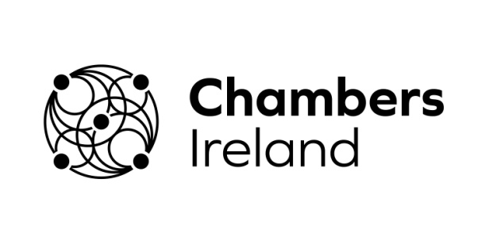
TRADE MATTERS
Exporter’s Stories from Irish Chamber Network

Existing Trade Deals
More info- http://ec.europa.eu/trade/policy/countries-and-regions/negotiations-and-agreements/#_partly-in-place

- What trade deals have you benefited from in the past?
- How long have you been trading with this/these market(s)?
- Has this trade deal helped benefit your business?
- Would you still export to this market if there was not a trade deal?
- How can benefiting from this trade deal be made easier for you? (Better access to information, simpler rules of origin, less trade documentation etc)

New trade deals (currently being negotiated)
- Are you aware of any new trade agreements being negotiated by the EU? (Japan, Mercosur/South America, Vietnam etc)
- Do you think your business will export into these new markets once the deals are finalised?
- Are there any markets where the EU does not have a trade deal that you would like to see one? (US, Australia, New Zealand etc)
- Do you have any recommendations or suggestions on how new trade agreements can be made more SME-friendly?

